# Chapter 4: Sound

**All Lectures Uploaded on YouTube:** [**https://tinyurl.com/fkm10-physics**](https://tinyurl.com/fkm10-physics)



## 13.1 SOURCE OF SOUND

A source of sound is any object that vibrates to produce sound. Examples include clapping hands, ringing bells, chirping birds, and musical instruments. Sound is produced when a vibrating object transfers energy to the surrounding medium, causing compressions and rarefactions.

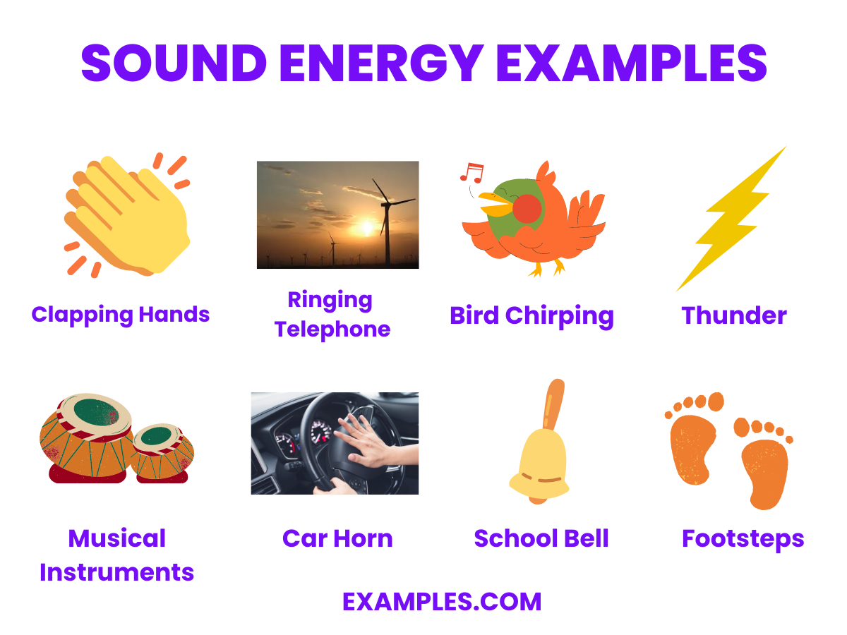

## 13.1.1 HOW SOUND IS PRODUCED?

* Sound production depends on vibrations. Vibrating objects disturb nearby particles, creating pressure waves.
* Examples: Plucking a rubber band, striking a drum, blowing across a bottle.
* Experiment: Hit a tuning fork, touch it to water; vibrations disturb water, producing sound.

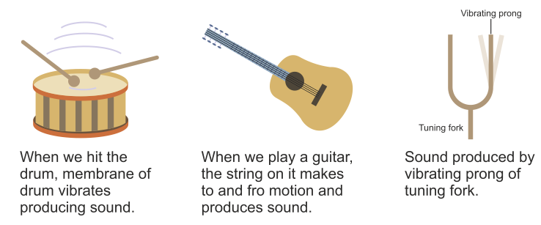

## 13.1.2 MEDIUM FOR PROPAGATION OF SOUND

* Sound is a mechanical longitudinal wave, so it requires a medium (solid, liquid, or gas).
* Bell Jar Experiment: Let's take an electric bell and an airtight glass bell jar. The electric bell is suspended inside the airtight bell jar. The bell jar is connected to a vacuum pump, as shown in figure. The electric bell inside a vacuum jar becomes inaudible as air is removed, proving medium is essential. 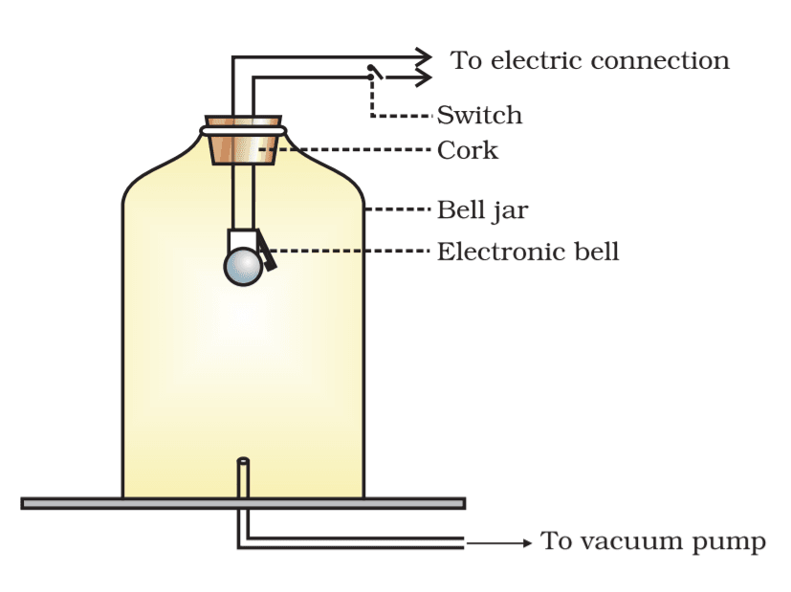

## 13.2 NATURE OF SOUND WAVES

Sound waves are mechanical longitudinal waves consisting of compressions and rarefactions (low pressure, high velocity).

Compressions: Compression is that high pressure portion within a sound wave, where molecules of medium acquire low velocity, which is produced due to vibrational kinetic energy of sound source.

Rarefactions: Rarefaction is that low pressure portion within a sound wave, where molecules of medium acquire high velocity within a sound wave which is produced due to vibrational kinetic energy of sound source.

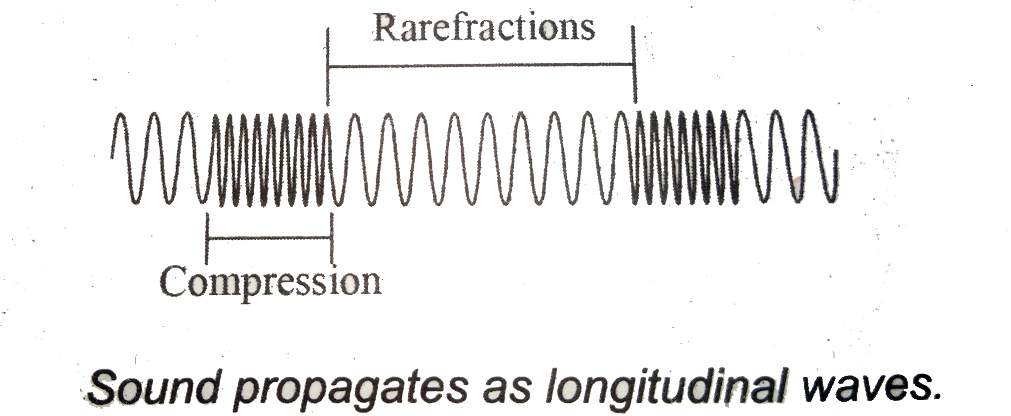

## 13.2.2 RELATED TERMS OF SOUND WAVES

* Wavelength (symbol: λ): Distance between two compressions or rarefactions. **Unit: meter.**
* Amplitude (symbol: A): Maximum displacement of particles, indicates energy level. **Unit: meter.**
* Frequency (symbol: f): Number of waves per second. **Unit: Hertz (Hz).**
* Time Period (symbol: T): Time for one cycle. **Unit: seconds.**

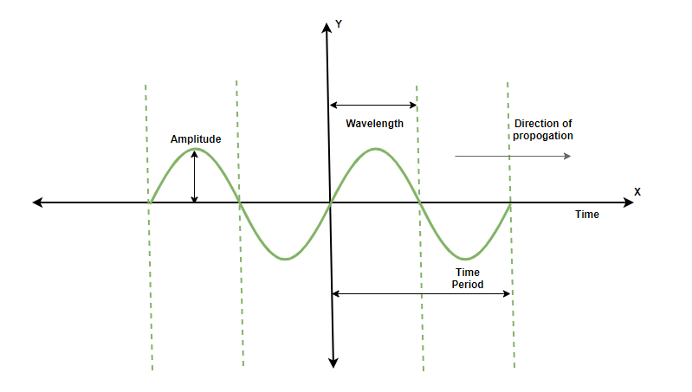

## 13.2.3 TYPES OF SOUND WAVES

There are two types of sound waves:

* Rhythmic sounds: Pleasant, periodic vibrations (e.g., music).
* Non-rhythmic sounds: Unpleasant, irregular vibrations (noise).
* Audible range: 20 Hz – 20 kHz; below = infrasound, above = ultrasound.

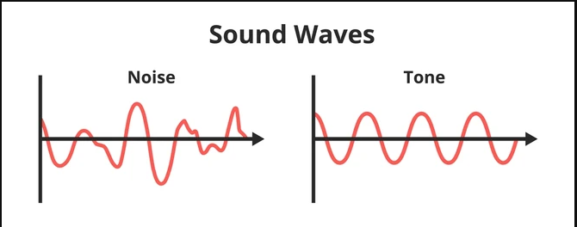

## 13.3 ULTRASOUND

* Ultrasound: Sound waves >20 kHz, inaudible to humans.
* Applications: Medicine, cleaning, sonar.

## 13.3.1 USES OF ULTRASOUND

1. Cleaning:
   1. Applications: High-frequency sound waves create bubbles that implode, cleaning surfaces (e.g., jewelry, surgical tools).
   2. Advantages: Non-damaging, reaches small and hard-to-clean areas, often only needs water or mild detergents.
2. Medical Scanning:
   1. Applications: Ultrasound transducers create images of organs. Advantages: safe, non-invasive, real-time imaging.
   2. Advantages: Non-invasive, safe (no harmful radiation), provides real-time images.
3. Sonar:
   1. Applications: Sound pulses detect underwater objects and measure depth using echoes.

## 13.3.2 CALCULATING DEPTH OR DISTANCE

Ultrasound can be used for measuring depth or-distance , it involves sending sound pulses from a ship to the ocean floor and measuring the time it takes for the echoes to return.

Formula:

$d=\frac{v×t}{2}$,

where v = speed of sound, t = round-trip time.

**Unit: meters (m).**

## 13.4 INFRASOUND

Infrasound, referred to as low frequency sound, describes sound waves with a frequency below the lower limit of human audibility (generally less than 20Hz).

Infrasonics find the following applications

* Used by elephants, whales, and giraffes for long-distance communication. They communicate warnings about potential threats and coordinate their movements. This form of communication enables them to stay connected over long distances and in areas with limited visibility, such as dense vegetation.
* Also produced in seismic activity (earthquakes, volcanoes). Specialized instruments called infrasound sensors detect these low-frequency sound waves to monitor seismic activity to predict earthquakes and volcanic eruptions. It provides early warnings for natural disasters.

## 13.5 CHARACTERISTICS OF SOUND WAVE

* **Pitch**: Perception of frequency (high frequency = high pitch).
* **Loudness**: Related to amplitude; measured in decibels (dB).
  + **Amplitude**: The loudness of a sound is directly related to the amplitude of the sound wave. Sound waves with a larger amplitude have more energy, which results in a louder sound.
  + **Distance from the Source**: As sound waves travel away from their source, their energy spreads out over a larger area. This reduction in energy per unit area, or intensity, causes the sound to become quieter as the distance from the source increases.
  + **Surface Area of the Vibrating Body**: A larger vibrating surface can set more air particles into motion. This increased vibration leads to more intense sound waves and, consequently, a louder sound.
  + **Sensitivity of the ears of listener**: More sensitive ears can feel more effect of loudness. In other words Sensitivity level of ears has direct relation with loudness of sound wave.
* **Quality (Timbre)**: Distinguishes sounds of same pitch and loudness (e.g., piano vs. violin).

## 13.6 ANALYZING SOUND WAVES

Oscilloscope is a device to display sound waves on a screen. Pure tones produce smooth sine waves while complex sounds (violin, piano) show complex waveforms with overtones.

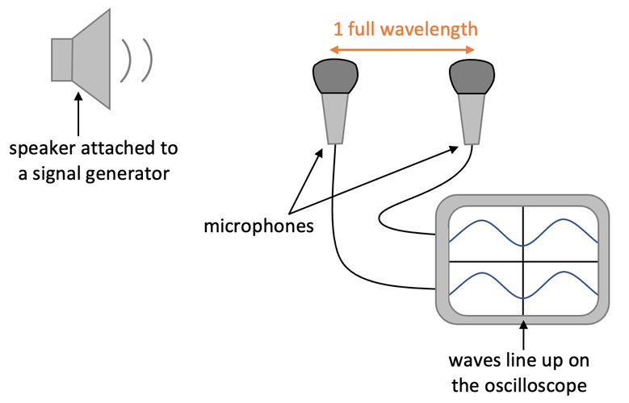

## 13.7 SPEED OF SOUND

The speed of sound can be defined as: The distance covered by sound wave per unit time is called speed of sound. Mathematically:

$speed=\frac{distance}{time}; v=\frac{d}{t}$

* **Unit: m/s**
* Depends on particle spacing, elasticity, and density.
* Fastest in solids (~5000 m/s), slower in liquids (~1500 m/s), slowest in gases (~343 m/s).

## 13.8 NOISE

In general; the term noise means unpleasant sound waves experienced by the listener.

* Sources: Factories, traffic, construction, public places.

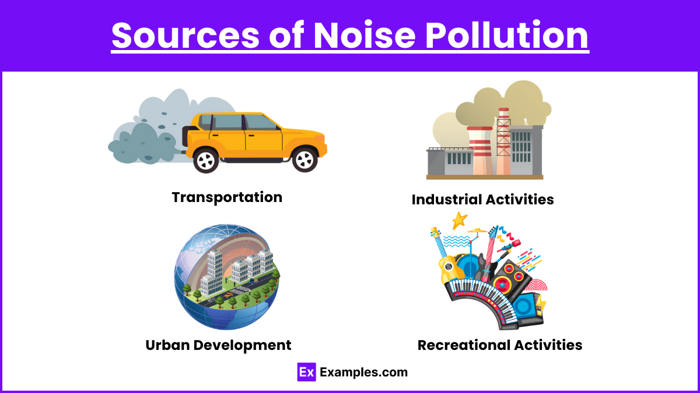

* Reduction: Earplugs, planting trees, acoustic materials, lowering volumes.

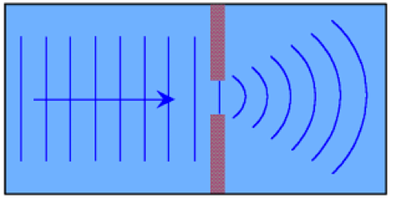

## 13.9.1,2,3. REFLECTION, REFRACTION AND DIFFRACTION OF SOUND

* Reflection: Bouncing back of sound (e.g., echo).
* Refraction: Bending of sound due to medium variation (e.g., temperature layers in air, water density layers).
* Diffraction: Spreading/bending of sound around obstacles or through gaps (e.g., hearing around corners).

## 13.10 ECHO

The term echo is the behavior of a sound wave by which it comes back to the listener after striking with any obstacle due to the Wave-reflection phenomenon. It is a reflected sound heard after 0.1s delay.

* Condition: Minimum 17 m distance required (at 340 m/s).

## 13.10.1 NECESSARY CONDITION FOR HUMAN HEARING OF ECHO

The human ear can perceive sound waves within 0.1 second. This value shows that two sound waves can be perceived if the time interval between both sound waves is 0.1 second. Due to above mentioned information the distance between source of sound and reflecting surface can be calculated as: Distance travelled by sound ‘D'=2d

Echo audible only if time gap ≥0.1s.

* Formula: $v=\frac{D}{t}$ or $D=v×t$
* $2d=v×0.1$ or $d=v×\frac{0.1}{t}$
* Therefore, $d=\frac{v}{20}$
* **Unit: meter (m)**

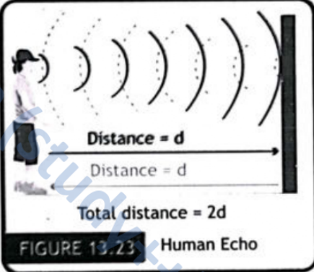

## 13.10.2 APPLICATIONS OF ECHO

* Applications: sonar, ultrasound, echolocation (bats, dolphins).
* Measures ocean depth and distances.

## 13.11 ACOUSTICS

It is that branch of physics which deals with study of sound; its characteristics, production, transmission, effects and so on. There are so many types of acoustics like; Environmental Noise, Musical Acoustics, Ultra-sounds, Infra-sounds, Vibration and Dynamics.

* Acoustics: Study of sound, its production, transmission, and effects.
* Includes environmental noise, musical acoustics, ultrasound, infrasound.

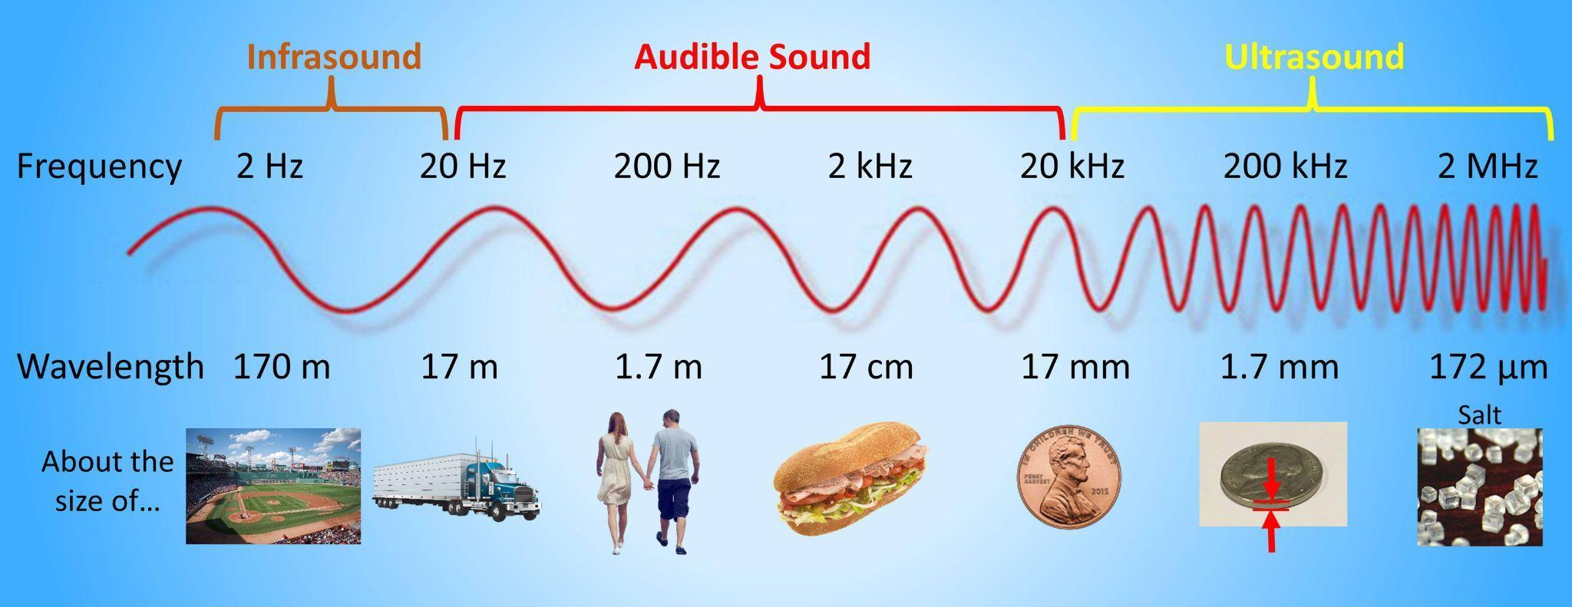

## 13.11.1 ACOUSTIC PROTECTION

The technique or method used to absorb undesirable sounds by soft and porous surface is called acoustic protection. Reflection of sound is more prominent if the surface is rigid and smooth, and less if the surface is soft and irregular.

* Soft porous materials (curtains, carpets, acoustic panels) absorb sound, reducing echoes and noise pollution.

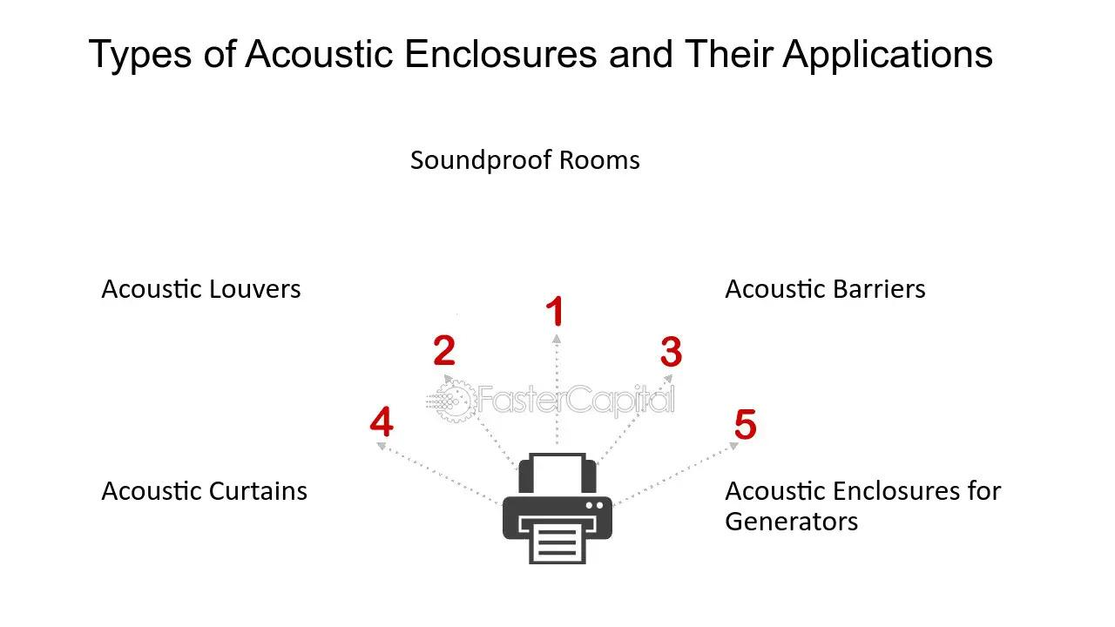

## 13.11.2 IMPORTANCE OF ACOUSTIC PROTECTION

* Health: Protects hearing, reduces stress.
* Productivity: Improves focus, reduces distractions in schools/workplaces.
* Community: Ensures quieter living environments, protects wildlife.
* Compliance: Meets building and noise safety regulations.

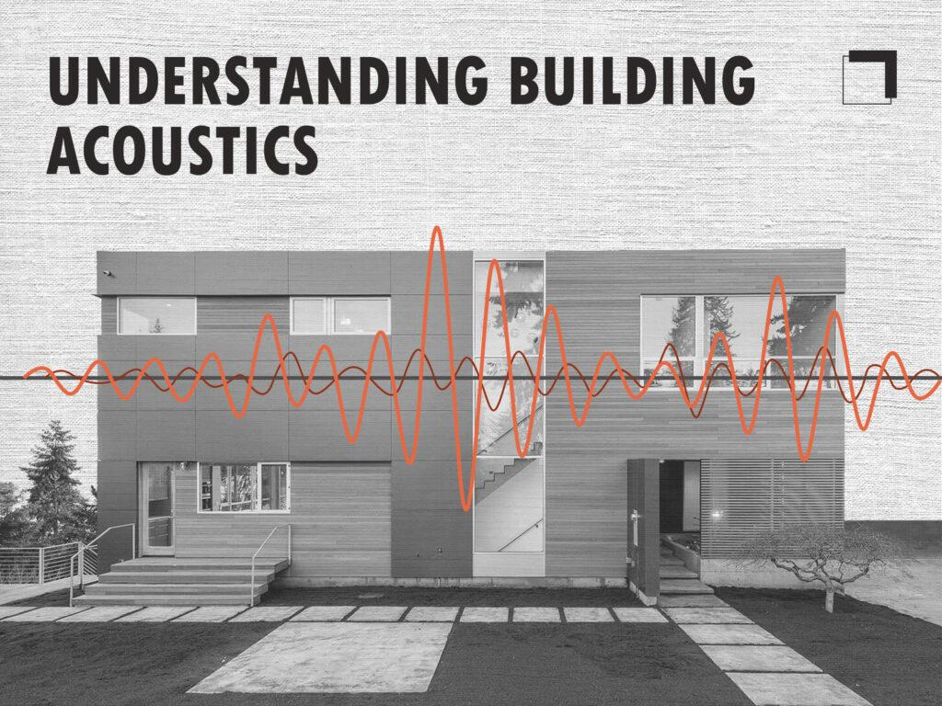

## 13.11.3 APPLYING ACOUSTICS IN BUILDING DESIGN

* Absorption: Carpets, acoustic panels reduce echo.
* Reflection: Materials like glass/concrete reflect sound for clarity.
* Transmission control: Insulated walls, windows prevent sound leakage.
* Diffusion: Irregular surfaces scatter sound evenly.
* Examples: Concert halls, offices, hospitals.

## 13.12 HUMAN HEARING SYSTEM

In physics, the process of converting sound into electrical signals that are interpreted by the brain involves several steps that can be described through the principles of wave mechanics, mechanical vibrations, and signal transduction.

1. Sound Waves Enter the Ear: Sound waves enter the ear canal and strike the eardrum.
2. Eardrum Vibration: The eardrum vibrates in response to these sound waves.
3. Ossicles Amplify Vibrations: Ossicles (malleus, incus, stapes) amplify vibrations.
4. Vibrations Enter the Cochlea: Vibrations pass into cochlea (fluid-filled).
5. Fluid Waves in the Cochlea: Cochlear fluid waves stimulate basilar membranes.
6. Hair Cells Detect Vibrations: Hair cells bend and detect vibrations.
7. Conversion to Electrical Signals: Hair cells generate electrical signals
8. Electrical Signals Travel to the Brain: Signals travel via the auditory nerve to the brain.
9. Brain Interprets the Signals

